**CHAPTER 1**

**INTRODUCTION**

**1.1 Introduction:**

We live in a world of technological advancement. Energy storage is a critical and growing need in the drive to increase the efﬁciency and effectiveness of power systems. In the quest for higher fuel efﬁciency, energy storage is becoming increasingly important in ground transportation. Renewable energy sources such as wind and solar require energy storage to buffer power production deﬁcits. Home energy storage can reduce costs by taking grid power during low-demand periods (e.g., at night) and reducing grid power during high-demand periods. There are many ways to store energy (e.g., ﬂywheels, ultra-capacitors, and compressed air) but batteries are the best choice for most applications. Batteries can be scaled from small (cell phone), to medium (HEVs), to large (grid) applications. They are highly efﬁcient and have high energy-to-weight ratios. There are safe and recyclable designs. Cost and battery life, however, are concerns that prevent more widespread application of batteries for energy storage applications. Researchers are continually inventing lower cost and longer life battery chemistries.

Nowadays, Lithium-ion batteries are used in various applications, ranging from personal electronic devices, like cell phones, to the emerging class of electric vehicles. Because of the fragile nature of this types of batteries, when compared to lead-acid or NiCd (Nickel-Cadmium) batteries, a comparatively advanced monitoring is necessary for safe operation.

The complexity of Battery Management Systems (BMS) strongly depends on the individual application. In simple case, like single cell batteries in mobile phones, or e-book readers, a simple “fuel gauge” Integrated Circuit (IC) like e.g., Texas Instruments bq27220 Single-Cell CEDV Fuel Gauge or Maxim Integrated MAX17048/MAX17049 Micropower 1-cell/2-cell Li+ModelGauge ICs can be sufficient. This ICs usually are able to measure voltage, temperature and current and use simple method to estimate the batteries current State of Charge (SOC). In more complex devices, like electric cars, the BMS has to fulfil more sophisticated tasks. In addition, the basic parameter like cell voltage, cell current and cell temperature have to be measured. Nevertheless, advance algorithms are needed as e.g., the available energy as to determine in order the reliable calculate the cruising range.

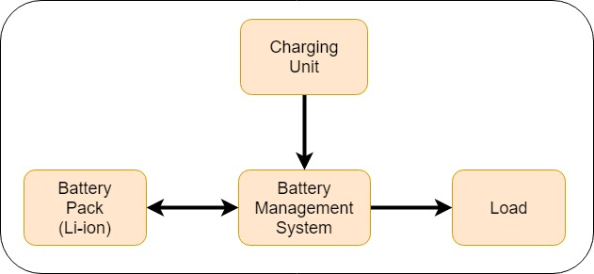 The general structure of Battery Management System (BMS) is shown in fig. 1.1. The BMS generally controlling the charge and discharge currents going into and out of the

*Fig.1.1 Basic structure of BMS system.*

Battery pack, limiting overcharge and undercharge in the cells, balancing the cells and maintaining safe operation of the pack. But the general Battery Management System (BMS) has a drawback that it does not give a real-time data of different parameters such as rate of drain current, charging current, cell voltage, cell temperature and charging and drain duration.

This project focuses on the hardware aspects of Battery Management System for Lithium-Ion batteries and digitizing the BMS for giving the real-time digitized data of various parameters such as charging current, cell voltage, cell current, cell temperature, battery pack overcharge and undercharge protection and thermal management system.

As in the world there is the era of renewable energy sources is going on, that’s why we are using the solar energy source as a power source. For that we are using a solar panel in this project to charge the batteries. The solar energy is most suitable for energy creation and we are able to easily convert the solar energy into the electrical energy through the solar panel. Another advantage of solar panel are; it has long life duration and they require very negligible maintenance.

To digitize the BMS we are using concept of “Internet of Things (IoT)”, which is more compatible for it and easy to use in the project. Along with the IoT we are also using the CAN (Controlled area network) to allow microcontrollers and devices to communicate with each other in applications without a host computer.

**CHAPTER 2**

**OVERVIEW OF LITERATURE**

**2.1 Introduction:**

When in the start of the term it was announced about Mega Projects, we searched many internet sites which provides us lot of information about projects. There we found variety of projects including software and hardware. As our specific interest was in hardware as well software, we found many interesting projects using hardware and software like Smart Farming, Deaf and Dumb Interpreter and many more. But after the announcement of i-360 program by SAP, we had gone through a various industrial project like connecting all the PLCs on network, Digitization of Series monitoring audit data, Energy Monitoring Solution and many more. As nowadays tremendous growth in the battery energy system is taking place we have finally chosen the project based on the Battery Management System.

As we finalized that we are going to do a project based on Battery Management System and Solar Power System along with the IoT to digitize the BMS. We gone through many electronics magazines like electronics for you, Autodesk, Auto Expo etc. We have also gone through searching various books related to our project. Among the no of books we referred two books described as follows.

**2.1.1 Books:**

1. **[1] “Battery System Engineering” by *Christopher D. Rahn* and *Chao-Yang Wang,* A. John Wiley & Sons Publication.**



*Fig. 2.1: Battery System Engg. Book.*

This book describes the multidisciplinary area of battery system engineering by providing the background, models, solution techniques and system theory that are necessary for development of the advanced battery management system. Anyone who is interested in learning more about advanced battery system will benefit from this book. By referring this book we got a tremendous amount of knowledge about battery management system. This book contents the designing of battery management system in consideration with the various battery pack parameters.

1. **[2] “SOLAR ENERGY ENGINEERING: PROCESSES AND SYSTEM” by *Soteris A. Kalogirou*, Elsevier Publication.**



*Fig. 2.2: Solar Energy Engg. Book.*

This book introduces a solar energy, its operation and how to design it. The material presented in this book covers a large variety of technologies for the conversion of solar energy to provide hot water, heating, cooling, drying, desalination and electricity. From this book we got an information about solar panel system. How the solar panel works, its construction, operation. In addition to that we got a knowledge about different type of solar panel.

* + 1. **Journal Papers:**

1. **[3] G.H. Kim and A. Pesaran, (November 2006), “Battery Thermal Management System Design Modeling”, *National Renewable Energy Laboratory, Conference Paper* NREL/CP-540-40446.**

Battery thermal management is critical in achieving performance and extended life of batteries in electric and hybrid vehicles under real driving conditions. Appropriate modelling for predicting thermal behaviour of battery systems in vehicles helps to make decisions for improved design and shortens the development process. For this paper, we looked at the impact of cooling strategies with air and both direct and indirect liquid cooling. The simplicity of an air battery cooling system is an advantage over a liquid coolant system. In addition to lower heat transfer coefficient, the disadvantage of air cooling is that the small heat capacity of air makes it difficult to accomplish temperature uniformity inside a cell or between cells in a module. Liquid cooling systems are more effective in heat transfer and take up less volume, but the added complexity and cost may outweigh the merits. Surface heat transfer coefficient, h, and the blower power for air cooling are sensitive to the hydraulic diameter of the channel (Dh). However, because of the added thermal resistances, h evaluated at cell surface is not as sensitive to the variation of Dh in a water/glycol jacket cooling system. Due to the high heat transfer coefficient at small Dh and large coolant flow rate, direct liquid cooling using dielectric mineral oil may be preferred in spite of high pressure loss in certain circumstances such as in highly transient large heat generating battery systems. Results of computational fluid dynamics (CFD) model simulation imply that capturing the internal heat flow paths and thermal resistances inside a cell using a sophisticated three-dimensional cell model are important for the improved prediction of cell/battery thermal behaviours. This paper identified analyses and approaches that engineers should consider when they design a battery thermal management system for vehicles.

1. **[4] B. P. DIVAKAR, K. W. E. CHENG, H. J. WU, J. XU, H.B.MA, W. TING, K.DING, W.F.CHOI, B.F. HUANG, C.H. LEUNG (15 April 2016.),“Battery Management System and Control Strategy for Hybrid and Electric Vehicle”, *3rd International Conference on Power Electronics Systems and Applications (2009).***

This paper gives us the information about battery management system. The paper describes, Battery management system (BMS) is an integral part of any electrical vehicle, which ensures that the batteries are not subjected to conditions outside their specified safe operating conditions. Thus the safety of the battery as well as of the passengers depend on the design of the BMS. In the present work a preliminary work is carried out to simulate a typical BMS for hybrid electrical vehicle. The various functional blocks of the BMS are implemented in SIMULINK toolbox of MATLAB. The BMS proposed is equipped with a battery model in which SOC is used as one of the states to overcome the limitation of stand-alone coulomb counting method for SOC estimation. The parameters of the battery are extracted from experimental results and incorporated in the model. The simulation results are validated by experimental results.

**2.2 Need for Present Study:**

1. To controlling the charge and discharge currents going into and out of the battery pack, respectively.
2. To limit the overcharge and undercharge in the cells of battery pack (Li-ion).
3. To ensure that the cells in the pack are balanced or not.
4. To maintain the safe operation of the battery pack (Li-ion).
5. To store the solar energy in battery pack by Solar Panel.
6. To digitally extract the operating parameters from the BMS.

**2.3 Proposed Approach:**

The aim of our project is to digitalize the existing Battery Management System using IoT and various techniques. The main purpose of this project is to make system easily understandable to the consumer by showing the real-time parameter of the system to it and charge the batteries by cost free solar energy using solar panel.

**2.4 Objectives and Scope:**

* To monitor & control each cell in the battery pack by measuring its parameters.
* To control and monitor the charge & discharge current going into and out of the battery pack.
* To limit the overcharging and undercharging of cells.
* To maintain safe operation of the pack.
* To Monitor the cells temperature and control the thermal management systems to maintain the pack within a speciﬁed temperature range.
* To efficiently convert the solar energy into the electrical one and preserving it.
* To make all above objectives simply understandable and controllable by the consumer by introducing concept of “Internet of Things” (IoT), Cloud Computing and displaying it on display (i.e. on Website / Local monitor LCD display) .
  1. **Scope:**
* The performance of the system can be further improved in terms of the operating speed, memory capacity and instruction cycle period of the microcontroller by using other controller.
* We can protect the data travelling between system and client by encrypting and having password as client side. Because of that only allowable client can see the data and control it.

**CHAPTER 3**

**PROJECT DEFINITION AND SPECIFICATIONS**

**3.1 Project Definition:**

The aim of this project is to digitalized the energy storing, dissipating, controlling and converting system (like batteries, Battery Management System and Solar Panel Respectively) by introducing concept of “Internet of Things” (IoT), Cloud Computing and displaying it on display (i.e. on Website / Local monitor LCD display) and make it simple to understand and manageable to the consumer.

**3.2 Specifications:**

**3.2.1 System Specifications:**

* Battery Pack Capacity: 3000 Watt.
* Battery Pack Cell Type: Lithium-Ion (Li-ion).
* Solar Panel Model: Panasonic VBHN325SA16.
* Solar Charge Controller: NavSemi Energy Imax 40(48V) MPPT.
* Cell Balancing & Monitoring IC: bq76PL536.
* Controller: TMSx70 C2000 Battery System Controller.
* Microcontrollers: Node MCU ESP8266.

**3.2.2 Input and Output Specifications:**

1. **Input Specification:**
2. Voltage (Max): 57.6 V.
3. Current (max): 5.65 A.
4. **Output Specification:**
5. State Of Battery Pack Cell Temperature.
6. State of Battery Pack Cell Voltage.
7. Rate of input voltage and input current from solar panel.
8. Estimated battery pack charging time.
9. Battery pack draining rate.

**3.2.3 Hardware Specifications:**

1. **Battery Management System:**

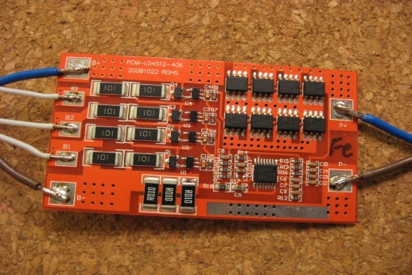

*Fig.3.1: BMS.*

* Balance start voltage: 3.5 V.
* Balance end voltage: 3.6 V.
* Maximum diverted current per cell: up to 1.3 (3.9 Ohm) A.
* Cell over voltage switch-off: 3.8 V.
* Cell over voltage switch-off hysteresis per cell: 0.015 V.
* Charger end of charge switch-off pack: 3.6 V.
* Cell under voltage protection switch-off: 2.2 V.
* Cell under voltage protection alarm: 2.6 V.
* Cell under voltage protection switch-off timer: 4sec.
* Cells max difference: 0.2 V.
* BMS maximum pack voltage: 62.5 V.
* BMS over temperature switch-off: 50 °C.
* Cell over temperature switch-off: 60 °.
* Under temperature charging disable: -15 °C.

1. **Solar Panel:**

* Model: VBHN325SA16
* Rated Power (Pmax)¹: 325W
* Maximum Power Voltage (Vpm): 57.6V
* Maximum Power Current (lpm): 5.65A.

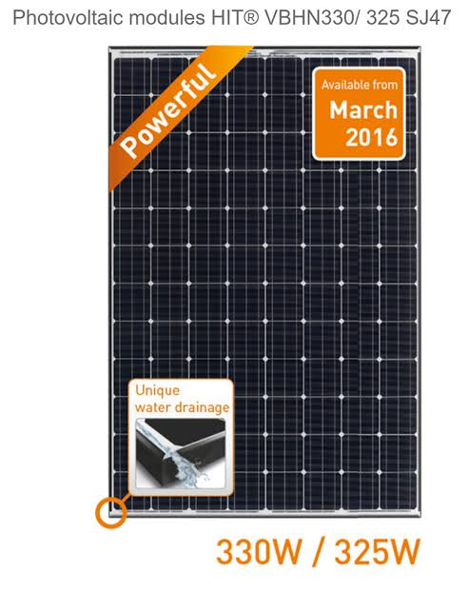

*Fig. 3.2: Solar Panel*

* Open Circuit Voltage (Voc): 69.6V
* Short Circuit Current (lsc): 6.03A
* Temperature Coefficient (Pmax): -0. 30%/°C
* Temperature Coefficient (Voc): -0. 174V/°C
* Temperature Coefficient (lsc): 1.82mA/°C
* CEC PTS Rating: 301.7W
* Cell Efficiency: 21.76%
* Module Efficiency: 19.4%
* Watts per Ft.²: 18.0W
* Maximum System Voltage: 600V
* Weight 40.81 Lbs. (18.5kg)
* Dimensions LxWxH: 62.6x41.5x1.4 in. (1590x1053x35 mm)
* Cable Length +Male/-Female: 40.2/40.2 in. (1020/1020 mm)
* Cable Size / Type No.: 12 AWG / PV Cable
* Connector Type2 Multi-Contact: Type IV (MC4™)
* Operating Temperature: -40°F to 185°F (-40°C to 85°C)

1. **Solar Charge Controller:**

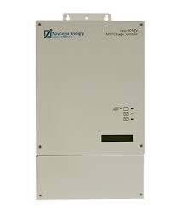

*Fig. 3.3: Solar Charge Controller.*

* Model; Imax 40 (48V).
* Maximum Power Handling (Wp): 2000
* Maximum Voltage Open Circuit (V): 150
* Operating Voltage Range(V): 60-120
* Max Short Circuit Current (Isc): 20 A
* Typical Battery Voltage (V): 48
* Battery Low (V) [Red LED]: 43.2
* Battery Low Alarm (V) [Yellow LED]: 45.6
* Boost cut-off (V): 58.8
* Float charge voltage (V): 54.4
* Maximum charging current (A): 40
* Self-consumption: <1.3 W OTHER

1. **Node MCU ESP8266EX:**

* Storage Temperature Range: -40oC to 125oC.
* Working Voltage: 3.0V, 3.3V, 3.6V.
* Maximum I/O current (Imax): 12mA.

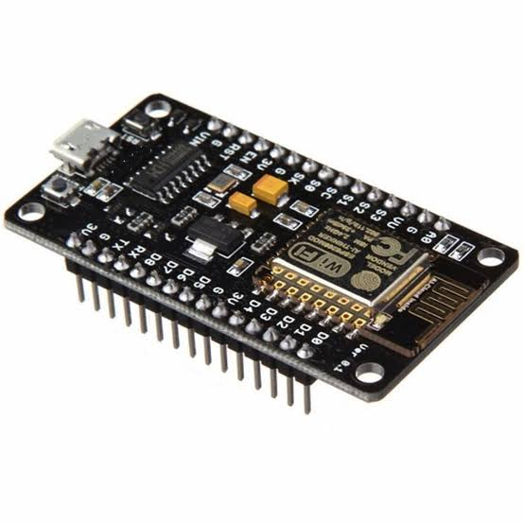

*Fig. 3.4: Node MCU ESP8266EX*

* Wi-Fi Protocols: 802.11 b/g/n.
* Frequency Range: 2.4GHz-2.5GHz.
* Types of antenna: PCB Trace, External, IPEX Connector, Ceramic Chip.
* Peripheral Bus: UART/SDIO/SPI/I2C/IR Remote Control.
* Ambient Temperature Range: Normal Temperature.
* Package Size: 5x5 mm.
* Wi-Fi mode: Station/softAP/softAp + station.
* Security: WPA/WPA2.
* Network Protocols: IPv4, TCP/UDP/HTTP/FTP.
* User Configuration: AT Instruction set, Cloud Server, Android/iOS App.

**3.2.4 Software Specification:**

* Proteus.
* MATLAB.
* Arduino IDE.
* Energia IDE.
* Code Composer Studio.

**CHAPTER 4**

**METHODOLOGY**

**4.1 Block Diagram:**

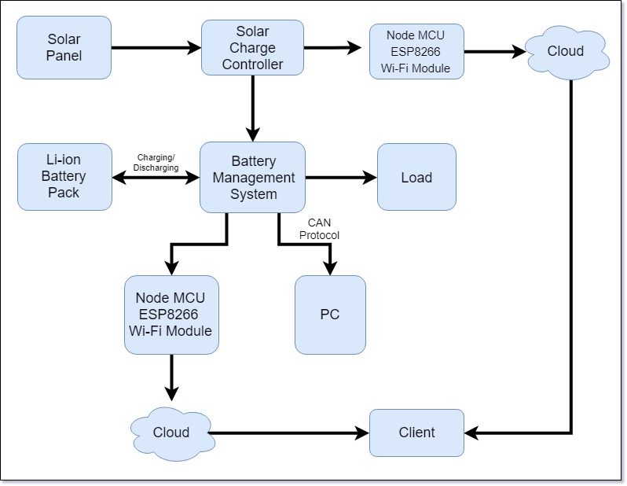

*Fig. 4.1: Block Diagram.*

**4.1.1 Internal Block Diagram of BMS:**

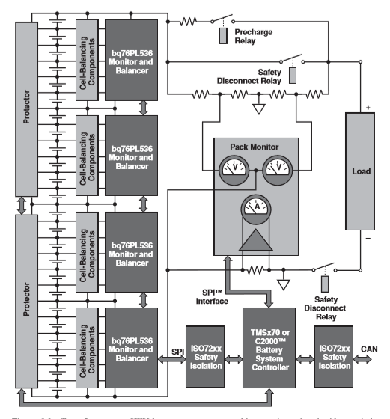

*Fig. 4.2: BMS Internal Block Diagram.*

**4.2 Block Diagram Explanation:**

The Block Diagram of project is as shown in fig. 4.1. It consist of following blocks.

Solar Panel, Solar Charge Controller, BMS, Lithium-ion Battery Pack, Node MCU ESP8266 Wi-Fi Module and PC. The description of each block is describes as follows.

The Fig. 4.2 shows the internal structure of the BMS. It consist of various components such as Protector Circuitry, Cell- Balancing IC’s, Cell Monitoring IC’s, different switching circuitry, Controller (TMSx70/C2000) and Safety Isolation.

**4.2.1 Solar Panel:**

A solar panel is actually a collection of solar (or photovoltaic) cells, which can be used to generate electricity through photovoltaic effect. These cells are arranged in a grid-like

Pattern on the surface of solar panels. Thus, it may also be described as a set of photovoltaic modules, mounted on a structure supporting it. In our project we are using a solar panel of “Monocrystalline” type and the manufacturing technology is “Heterojunction with Intrinsic Thin-Layer (HIT)” which provide the high efficiency of solar panel up to 19.6%.

**4.2.2 Solar charge controller:**

A charge controller is basically a voltage and/or current regulator to keep batteries from overcharging. It regulates the voltage and current coming from the solar panels going to the battery. Normally the solar panel provides the output voltage from 50-56 V and current from 6-9 A. The battery pack requires only 46 - 48.5 V for charging. To limit the supplied power we are using solar charge controller. Another reason to use solar charge controller is at the dark time solar panel is not giving any output power. In such condition a reverse power can be flows from battery to solar panel which may result to damage solar panel. The charge controller also take care of that. In our project we are using MPPT (Maximum Power Position Transfer) technology charge controller, which gives a maximum required output to fast charging of batteries.

**4.2.3 Battery management system (BMS)**

Battery management system is not controllers. Instead, they monitor your battery system and give you a pretty good idea of your battery condition, and what you are using and generating. They keep track of the total amp-hours into and out of the batteries, and the battery state of charge, and other information such as which battery pack is being damaged and which pack is overcharged or under charged. They can be very useful for medium to large systems for tracking exactly what your system is doing with various charging sources.

Battery management system (BMS) is a device that monitors and controls each cell in the battery pack by measuring its parameters. The capacity of the battery pack differs from one cell to another and this increases with number of charging/discharging cycles. The Li-poly batteries are fully charged at typical cell voltage 4.16 - 4.20 V. Due to the different capacity this voltage is not reached at the same time for all cells in the pack. The lower the capacity the sooner this voltage is reached. When charging series connected batteries with single charger, the voltage on some cells might be higher than maximum allowed charging voltage at the end of charging. Overcharging the cell additionally lowers its capacity and number of charging cycles. The BMS equalizes cells’ voltage by diverting some of the charging current from higher voltage cells – passive balancing. The device temperature is measured to protect the circuit from over-heating due to the passive balancing. Battery pack temperature is monitored by digital temperature sensor/s.

.

**4.2.4 Fuses:**

Fuses are used in the circuit so that the circuit should be protected from over voltage spikes that can damage the costly battery management system in our circuit.

**4.2.5 Node MCU ESP8266:**

It is a powerful Wi-Fi module which consist an on-chip controller in it. It is using 802.11 Wi-Fi protocol. We are getting input signal from solar charge controller and battery management system. Using ESP8266 we are sending this data to the cloud.

**4.2.5 System:**

A general system that is capable enough to run Scada software that will display the present/current values of the system i.e. battery charging percentage and charging/discharging rate through.

**4.3 Design Stages:**

**4.3.1 Circuit Diagram:** 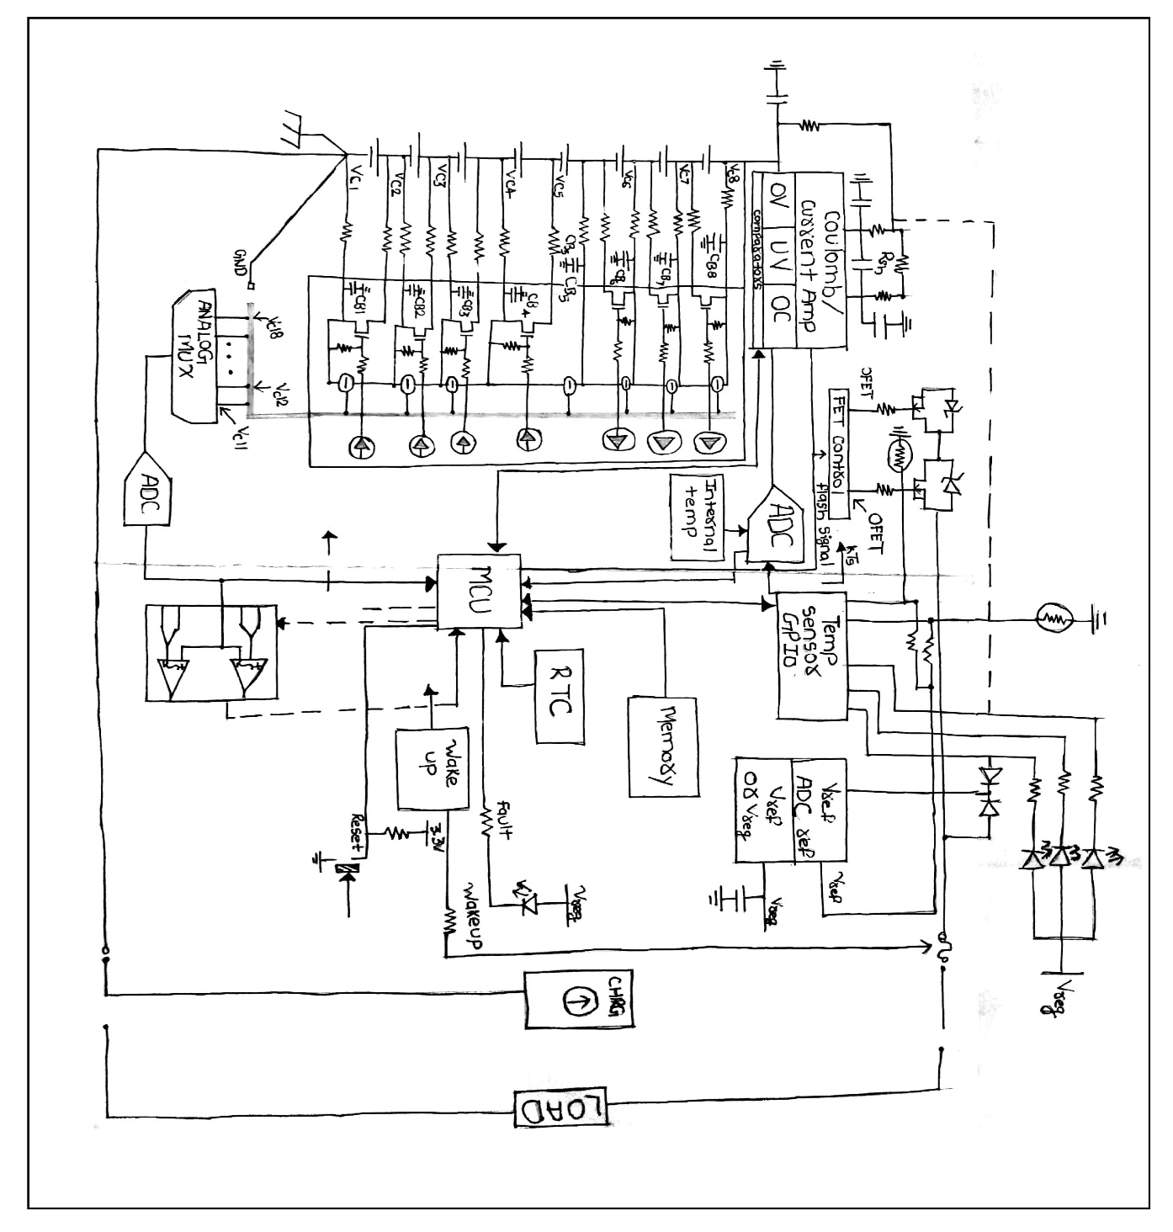

*Fig. 4.3: BMS Circuit Diagram*

**4.4 Software Design:**

**4.4.1 Flow Chart:**

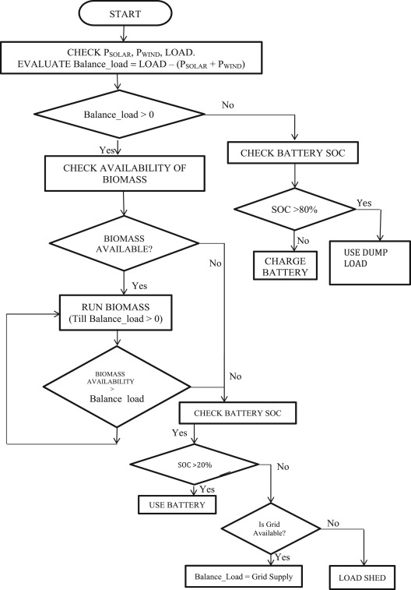

*Fig. 4.4: Flowchart.*

**CHAPTER 5**

**CONCLUSIONS**

**4**

**5.1 Advantages:**

1.

**5.2 Applications:**

1. Hybrid Electric Vehicles.

2. Solar Electric Vehicles.

3. Solar Grid Application.

**5.3 Conclusions:**

Battery management systems can be architected using a variety of functional blocks and design techniques. Careful consideration of battery requirements and battery life goals will guide you in determining the right architecture, functional blocks and related ICs to create your battery management system and charging scheme to optimize battery life. Solar Panels are best way to store cost free solar energy into the battery. The digitized Battery Management System give great help to understand the Battery Management System and Battery parameters.

**CHAPTER 6**

**PROPOSED TIME PLAN AND ACTIVITIES**

|  |  |  |  |  |  |  |  |  |  |  |  |  |
| --- | --- | --- | --- | --- | --- | --- | --- | --- | --- | --- | --- | --- |
| PHASE | SEMESTER-1 | | | SEMESTER-1  EXAMINATION | | | SEMESTER-2 | | | SEMESTER-2  EXAMINATION | | |
| JULY | AUG | SEP | OCT | NOV | DEC | JAN | FEB | MAR | APR | MAY | JUN |
| Literature  Survey |  |  |  |  |  |  |  |  |  |  |  |  |
| Project  Selection |  |  |  |  |  |  |  |  |  |  |  |  |
| H/W  Design  Phase |  |  |  |  |  |  |  |  |  |  |  |  |
| PCB  Design |  |  |  |  |  |  |  |  |  |  |  |  |
| Mechanical  Assembly |  |  |  |  |  |  |  |  |  |  |  |  |
| S/w  Design  Phase |  |  |  |  |  |  |  |  |  |  |  |  |
| Testing |  |  |  |  |  |  |  |  |  |  |  |  |
| Enclosure |  |  |  |  |  |  |  |  |  |  |  |  |
| Project report preparation |  |  |  |  |  |  |  |  |  |  |  |  |
| Submission Of Project Report |  |  |  |  |  |  |  |  |  |  |  |  |

*Table 6.1: Proposed Time Plan & Activity*

**REFERENCES**

**Book**

[1]Christopher D. Rahn and Chao-Yang Wang,*“Battery System Engineering”*A. John Wiley & Sons Publication.

[2]Soteris A. Kalogirou,*“SOLAR ENERGY ENGINEERING: PROCESSES AND SYSTEM”***,** Elsevier Publication.

**Conference and Symposia paper**

[3] G.H. Kim and A. Pesaran, (November 2006),*“Battery Thermal Management System Design Modeling”,* National Renewable Energy Laboratory, Conference Paper NREL/CP-540-40446.

[4] B. P. DIVAKAR, K. W. E. CHENG, H. J. WU, J. XU, H.B.MA, W. TING, K.DING, W.F.CHOI, B.F. HUANG, C.H. LEUNG (15 April 2016.), *“Battery Management System and Control Strategy for Hybrid and Electric Vehicle”,* 3rd International Conference on Power Electronics Systems and Applications (2009).

**Web Pages and On-line Material:**

[5]K.W.E. Cheng (2015). “Battery Management System and Control Strategy for Hybrid and Electric vehicle”

<<https://www.researchgate.net/publication/224585947>.>